student: Trang-nhung pham

student id: 11896558

march 7, 2018

Assignment 1

digital solution for a Communication challenge

word count: 1965 words

Alongside its growing popularity in the past years, social media has become an important tool of communication for organizations across industries thanks to its potential to democratize voice and facilitate participation, discourse and community formation (Macnamara & Zerfass, 2012, p. 287). In line with this trend, non-profit organizations, especially small-scale ones, have increasingly utilized social media in their communication strategies (Curtis et al., 2010) to promote civic participation of individuals and communities that are previously marginalized (Cheong & Yang, 2017). According to the 2017 Global NGO Online Technology Report, 92% of NGOs have a Facebook page, 72% have a Twitter account, the figures for YouTube, Linkedin and Instagram are 55%, 51% and 39% respectively (Nonprofit Tech for Good, 2017).

In the field of conservation, advance of social media has been welcomed wholeheartedly. It offers an effective tool and a space for environmentalists to expand their reach, engage the public in participation of conservation campaigns, strengthen the power of the "crowd", and empower independent activists (Dosemagen, 2016). New technologies have brought about opportunities for activists, especially environment ones, to self-represent, get information, build networks, mobilise the public, and form discourse community for their aims (Sima, 2011, p.477).

An example of social media's empowering potential is the development of grassroot conservation group Save Son Doong in Vietnam. The group was established following the discovery of Son Doong Cave in central Vietnam, which is the largest known cave passage cross-section in the world as of 2009. Save Son Doong group works to protect the natural environment in the cave's neighbourhood against potential destruction caused by tourism investment. Social media in this case provides the group great opportunities to obtain a large supporter base and awareness with modest resource. In fact, Facebook has become the main communication platform of this grassroot NGO.

Communication is important for NGOs to develop deeper and more meaningful relationship with the public (Orgad & Vella, 2012) so that they can secure support for their work. Piñeiro (2008) categories five specific communication practices that environmental communication follow: journalistic practice to disseminate information, advertising practice to promote environment-friendly behaviours, educational practice, interpretative practice to encourage individual reflection, and new technologies practice for research purposes (quoted in Núñez & Moreno (2016)).

For environment NGOs, communication strategy does not only increase awareness but helps with behavioural change as well. Changing individual behaviour so that people support pro-environmental positions, maintain favourable attitude towards conservation intention, and generate conservation behaviours is centre in their communication strategy. Communication of environment NGOs therefore is close to a work of persuasion (Núñez & Moreno, 2016).

This requirement of engaging the public makes communication of conservation NGOs much more arduous. It also highlights a typical challenge for communication of these NGOs: the distance between communication and engagement. Encouraging the public to participate in conservation activities is much harder than make them aware of conservation work being done.

Considering social media communication, this challenge is more clearly reflected in the problem of clicktivism. Though social media facilitate the support and spread of conservationist messages rapidly and dynamically, this interaction is often prone to a short-term lifetime rather than long-term involvement and deep engagement (Dosemagen, 2016). Conservation communication is of little significance if the clicktivism does not translate into real life changes, a viral conservationist content should mean more than being "liked" millions of time. Therefore, making social media users ultimately engage in conservationist content is an essential challenge that conservationist groups need to overcome.

But what does that mean by engagement? On social media platforms, engagement is often defined as any action taken by users on a page. Engagement rate is calculated by dividing engagement volume by base volume. There are three different types of metrics used to calculate base volume for engagement: followers, reach, and impression. Followers signify the number of social media users that follow or like an account/page. Reach signifies the number of users exposed to the content of the page, regardless of whether they follow the page or not. Impression are the number of views for the content or the page. For each type of volume base the engagement rate would be different while there is no consensus on a single metrics.

Similarly, there is no single criterium for being "viral" on Facebook, which makes it hard to evaluate the performance of pages and set future goals for social media communication strategy. A classic rule to be observed is the 90-9-1 rule of inequality participation for social network (Brandtzaeg & Heim, 2011). Accordingly, a page naturally gets the engagement by audience rate of 1%, 9% of its audience would irregularly engage and 90% of them goes unengaged with the page. Another finding by Schwartz suggests that on average, non-profits sites have the engagement rate of 0.27%, the figure for across industries is a bit lower, at 0.17% (Schwartz, 2017). Both figures are low considering the aim of environment communication, pressing the need for conservation groups in general to find solutions to increase engagement.

Save Son Doong group has a huge number of fans on Facebook (more than 222,000 likes as of March 2018) with around 1-2,000 likes and less than 50 comments for usual posts. Compared with the figures mentioned above, its Facebook page is doing at the average level, which means there is space for improvement. Specifically, reaction count of the page is quite good though comment count does not seem that promising.

In order for the task to be fulfilled, it is very importance to know how the group's social media communication works. Researching whether social media communication by Save Son Doong generate good engagement from audience and which type of content encourages the most engagement is the aim of this research.

In order to answer the research question: "*Which type content on Save Son Doong Facebook page generate more active engagement?*", three sub-research questions are set.

Firstly, the research would test if the usual claim that photo got the highest engagement rate while status receives the lowest engagement rate (Schwartz, 2017) applies to the case of Save Son Doong group. Sub-research question 1 therefore is:

*Which medium of content (photo, video, text, link) generates the highest level of engagement?*

Secondly, the research tries to find out any correlation between engagement and other content characteristics, with sub-research question 2 as following:

*Does the length of post, content's sentiments, involvement of celebrity, or inclusion of question help increase engagement?*

Content of posts plays a role in engagement of audience. It is argued that the public is more likely to make comments on two-way asymmetry communication as this appears as an effort of the organizations to build relationships with them (Cho, Schweickart, & Haase, 2014, pp. 566-567). Hence, sub-research question 3 is:

*Which type of content would generate more engagement by audience? Is it neutral knowledge sharing, call-in-action activist, or critic content that makes people more prone to voice their ideas?*

The research requires data of performing metrics and content of Facebook posts by Save Son Doong group. Two types of data would be obtained to conduct the analysis: Facebook Insights and Facebook page data from Netvizz. Facebook Insights is a useful tool to track the performance and user interaction of the Facebook page over time. With data dating back to a quarter, detailed description of key performance indicators of user engagement, reach and impressions can be obtained.

Netvizz is a veritable data extractor to obtain data from different sections of Facebook including personal profiles, groups and pages in standard formats (Rieder, 2013, p.348). The application provides data in two types: network and tabular files. For the purpose of this research, tabular data of the latest 200 posts published by Save Son Doong will be used. According to customs in social science research, each group of data should have around 50 to 80 events (Reinard, 2006, p. 40), therefore this sample is effective enough for studying post performance. Besides, regarding the average posting behaviour of Facebook pages at 1.40 posts per day (Schwartz, 2017), the number of posts chosen probably covers a period of five months to one year, a long enough period of time for the study.

As the centre dependent variable of the research, engagement should be clearly defined. Usually Facebook engagement is operationalised as the total count of reactions, shares and comments. However, engagement should not be a solid figure. Of the three types of engagement: like, share and comment, comment is the highest level of engagement (Cho, Schweickart, & Haase, 2014, p.565). In this research, each type of engagement will be analysed separately with proper attention paid to comment.

Independent variables can be obtained from post-related data. Post type can be used right away as an independent variable to answer question 1, but to answer the two other questions new variables of content categories and content factors are to be defined from post content, as shown in Table 1.

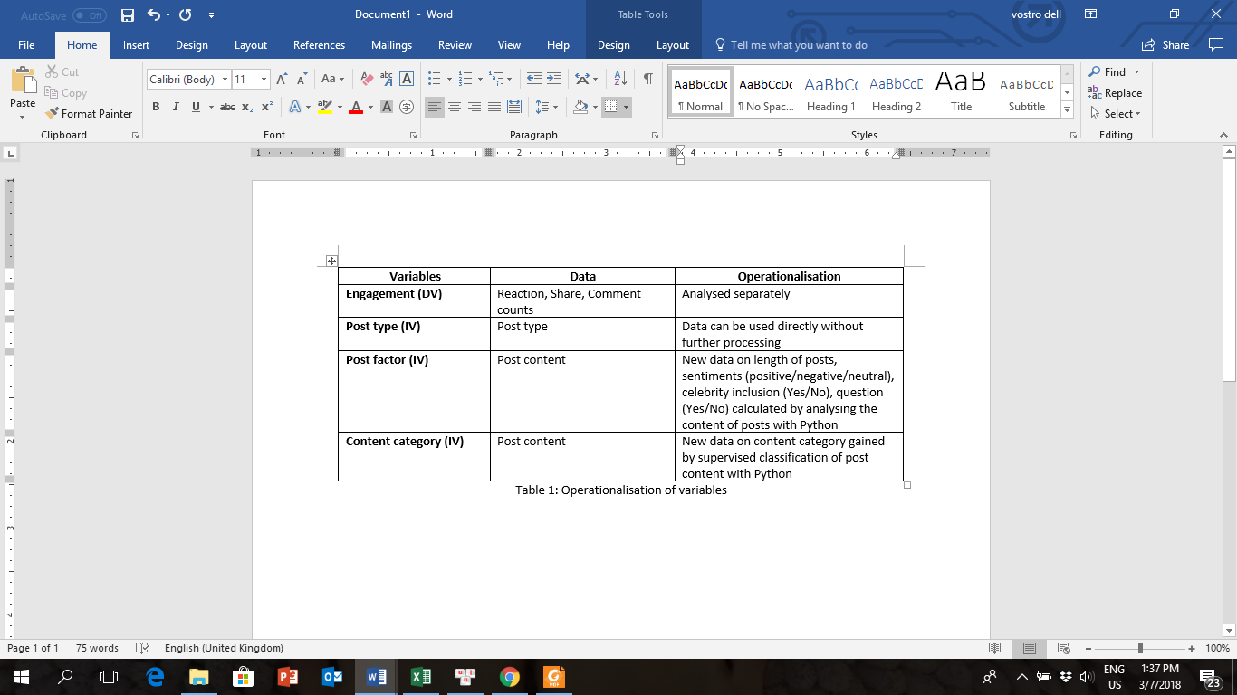

Before the main analyses are conducted, some pre-processing steps are required including cleansing, transformation, selection and discretization. Firstly, data gained needs to be cleansed to get rid of invalid entries, impute missing values, smooth out noise, and avoid duplication. Types of data also need examining and converting into workable types if needed. With the purpose of this research, data selection, extraction and merging are needed so that useful data is kept in a manageable set. Finally, supervised classification can be done to put data into meaningful categories for effective analysis afterwards. For example, to prepare for the analysis required to answer sub-research question 3, post content need to be classified into three groups.

Of the four types of analysis that can be done with data: descriptive analysis, diagnostic analysis, predictive analysis, and prescriptive analysis (Wiencierz & Röttger, 2017), this research works with descriptive analysis to answer the three set questions. After independent variables are defined using Python functions, research questions can be answered by conducting regression analysis to examine relationship between variables.

The analysis plan proposed above has two main strengths. An obvious advantage is that this is a helpful task that can be done without too much human and material resource. For a small and novel group like Save Son Doong, the analysis plan is an effective and economic option to examine how its communication strategy works so that improvement can be conducted for more engagement from the public. Besides, social media research like this plan is useful to study the absolute behaviours of social media users. Facebook can serve as an observational device to examine what people really do rather than what they report doing (Rieder, 2013, p.347). Considering the issue of deliberate participation, there are differences between information that users provide when answering a survey questionnaire and what they actually do in reality. The data used in this research is created naturally by users as daily behaviours so it excludes any experimental effect that may distort behaviour due to human interaction (Mahrt & Scharkow, 2013, p.24).

While this analysis might raise ethical issues of using semi-public data, the concern is not severe in this case given the fact that information gathered are activities that users undertake on a public site rather than on their personal pages. However, there are other apparent limitations for consideration. Firstly it is easier to do descriptive analysis with Facebook data than finding reasons behind audience behaviours, therefore further examination should be paid to the significance of social context (Mahrt & Scharkow, 2013, p.23). Secondly, like other quantitative analysis, this data analysis plan runs the risk of losing in-depth information through generalization of materials.

With both strengths and weaknesses taken into account, it is proposed that the analysis plan is important and should be conducted. At the same time, it should be part of a larger effort to thoroughly study engagement rather than the only attempt to solve this communication challenge.

**References**

Brandtzaeg, P. B., & Heim, J. (2011). A typology of Socia Networking Sites Users. *Int. J. Web Based Communities*, *7*(1), 28–51. https://doi.org/10.1504/IJWBC.2011.038124

Cheong, P. H., & Yang, A. (2017). Chinese non-governmental organizations, media, and culture: communication perspectives, practices, and provocations. *Chinese Journal of Communication*, *10*(1), 1–11. https://doi.org/10.1080/17544750.2017.1275084

Cho, M., Schweickart, T., & Haase, A. (2014). Public engagement with nonprofit organizations on Facebook. *Public Relations Review*, *40*(3), 565–567. https://doi.org/10.1016/j.pubrev.2014.01.008

Curtis, L., Edwards, C., Fraser, K. L., Gudelsky, S., Holmquist, J., Thornton, K., & Sweetser, K. D. (2010). Adoption of social media for public relations by nonprofit organizations. *Public Relations Review*, *36*(1), 90–92. https://doi.org/10.1016/j.pubrev.2009.10.003

Dosemagen, S. (2016, January 28). *Huffington Post*. Retrieved from Social Media and Saving the Environment: Clicktivism or Real Change?: https://www.huffingtonpost.com/shannon-dosemagen-/social-media-and-saving-t_b_9100362.html

Macnamara, J., & Zerfass, A. (2012). Social Media Communication in Organizations: The Challenges of Balancing Openness, Strategy, and Management. *International Journal of Strategic Communication, 6 (4)*, 287-308.

Mahrt, M., & Scharkow, M. (2013). The Value of Big Data in Digital Media Research. *Journal of Broadcasting and Electronic Media*, *57*(1), 20–33. https://doi.org/10.1080/08838151.2012.761700

Nonprofit Tech for Good. (2017). 2017 Global NGO Online Technology Report About the Report.

Núñez, R. Y. C., & Moreno, C. O. J. (2016). Communication and environmental conservation: Advances and challenges in Latin America. *Revista Latina de Comunicacion Social*, *71*, 15–39. https://doi.org/10.4185/RLCS-2016-1082en

Orgad, S., & Vella, C. (2012). Who cares ? Challenges and opportunities in communicating distant suffering : a view from the development and humanitarian sector, (June). Retrieved from http://www2.lse.ac.uk/media@lse/POLIS/documents/Polis papers/12_0196-POLIS-Report-COVER-V7.pdf

Reinard, J. C. (2006). Chapter 2: Collecting Data on Variables. In J. C. Reinard, *Communication Research Statistics* (pp. 17-41). Sage.

Rieder, B. (2013). Studying Facebook via data extraction. *Proceedings of the 5th Annual ACM Web Science Conference on - WebSci ’13*, 346–355. https://doi.org/10.1145/2464464.2464475

Schwartz, C. (2017). *2017 Social Media Industry Benchmark Report.* Retrieved from https://www.rivaliq.com/blog/2017-social-media-industry-benchmark-report/

Sima, Y. (2011). Grassroots Environmental Activism and the Internet: Constructing a Green Public Sphere in China. *Asian Studies Review*, *35*(4), 477–497. https://doi.org/10.1080/10357823.2011.628007

Wiencierz, C., & Röttger, U. (2017). The use of big data in corporate communication. *Corporate Communications: An International Journal*, *22*(3), 258–272. https://doi.org/10.1108/CCIJ-02-2016-0015